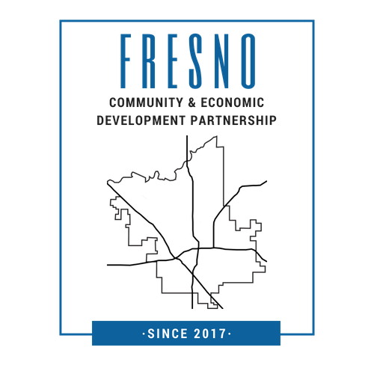
Fresno Community & Economic Development Partnership Project Specialist

Position Description
Under the general supervision of the Fresno CEDP HUB Coordinators, the Project Specialist would be responsible for developing and executing projects that advance the vision of the CEDP and the Missions of the CEDP Partners. The Project Specialist should be an inspiring leader capable of coaching, motivating and equipping our CEDP staff by providing ongoing support for their individual needs.
Status: Part-time
Hourly Rate: DOE
Responsibilities
1. Coordinate work responsibilities with HUB Coordinators on a weekly basis
2. Provide technical support to CEDP Partners in areas such as: (but not limited to)
- Bookkeeping & Financial Management
- Fundraising – Planning and Execution
- Grant Writing
- Marketing and Communications
- Basic Human Resources
- 990 Tax Support
3. Provide assistance with data collection, analyzing data and research
4. Coordinate CEDP meetings be they live or virtual. Provide notes for each meeting and assist with any logistics
5. Knowledge on virtual platforms
Requirements
Must be able to work with a diverse cross-section of our community and have a general understanding of our community. Must be comfortable working with varied economic, social, racial and cultural backgrounds. Have a passionate heart for community development work and be committed to excellence. Should be self-motivated, able to work by yourself and in teams. Have the ability to multi-task on a weekly basis.
The Project Specialist should have, at minimum, an AA Degree or higher and at least 2 years working in the nonprofit or community development field.
Must possess a valid California Driver’s License and verified automobile insurance along with use of a reasonably reliable auto for use on the job. Should have the ability to pass a Live Scan background fingerprinting check.
Application Process
Fresno CEDP HUB Coordinators are Fresno Metro Ministry and Every Neighborhood Partnership. To apply for this position please jointly email your resume and/or cover letter to the following:
Keith Berthold, Fresno Metro Ministry
keith@fresnometmin.org / 559.485.1416
Andrew Feil, Every Neighborhood Partnership
andrew@everyneighborhood.org / 559.400.7310

